F&O STRATEGY BACKTESTING FRAMEWORK
Nifty Options | Jan 2022 – Dec 2024
Performance Analysis & Strategy Recommendation Report
Team: Nalin Rajwar • Suhani Patnaik • Shivam Goyal
Quantitative Research & Investment Intelligence
Induma Internship 2026 | Group 1

1. Introduction

1.1 What is Backtesting?
Backtesting is the process of simulating a trading strategy on historical market data to evaluate how it would have performed in the past. Instead of risking real capital, a backtest replays past prices, applies a strategy's entry and exit rules mechanically, and records the resulting profit and loss (P&L) trade by trade. The output is a quantitative track record — total returns, win rate, drawdown, and risk-adjusted performance — that can be examined before any capital is deployed.
In the context of Futures & Options (F&O), backtesting is particularly important because options strategies are non-linear: their payoff depends on the underlying's price, time decay, and volatility simultaneously. A strategy that looks intuitively safe (such as selling a call against a futures position) can still produce large drawdowns if the underlying moves sharply against the position. Backtesting replaces intuition with evidence.

1.2 Why It Matters
F&O is India's largest financial market by trading volume, exceeding cash equities turnover on the NSE. Retail participation in options has grown sharply in recent years, yet most retail traders enter strategies based on tips or short-term sentiment rather than historical evidence. Every serious trader, prop desk, or fund manager validates a strategy's edge over multiple market cycles before committing capital. A backtesting framework answers one direct question:
“Would this strategy have made money over the last three years — and under what market conditions?”
This question matters more than a single profitable trade, because any strategy can get lucky once. What separates a robust strategy from a lucky one is consistency across different market regimes — trending, sideways, and falling markets — measured over a long enough sample.

1.3 What We Set Out to Test
This project designs and backtests four widely used options strategies on the Nifty index over a 3-year period (Jan 2022 – Dec 2024), spanning 36 months of live market data including the 2022 correction, the 2023 recovery, and the 2024 election-year volatility. The four strategies tested are:
- Covered Call — an income-generating strategy combining a long futures position with a short OTM call, executed monthly.
- Iron Condor — a range-bound, premium-selling strategy using four option legs, executed weekly.
- Bull Call Spread — a directional, limited-risk strategy for moderate upside views, executed monthly.
- Long Straddle — a volatility strategy designed to profit from large moves in either direction, executed around monthly expiry.
For each strategy we measure four core metrics — Total P&L, Win Rate, Maximum Drawdown, and Sharpe Ratio — and additionally classify performance by market regime (Trending Up, Sideways, Trending Down) to identify when each strategy works best. The objective is not to declare one strategy universally “best,” but to build a decision framework: which strategy should be deployed, and under what market condition.

2. Methodology

2.1 Data Collection
Historical Nifty options data was sourced from NSE BHAV copies (Bhav Copy = official daily settlement price files published by NSE) covering the period January 2022 to December 2024 — a full 36-month, 3-year window. Daily closing prices, strike prices, option type (CE/PE), and entry spot levels were extracted and cleaned for each contract using a Python data pipeline (data_loader.py), which filtered for valid Nifty CE/PE rows, removed entries with zero or missing prices, and resolved the at-the-money (ATM) strike dynamically from each day's closing spot price.
Each of the four strategies was then simulated independently using its own entry/exit logic, executed across all 36 months (Iron Condor was run weekly, given its shorter holding period, producing 140 individual trades; the remaining three strategies were run monthly, producing 36 trades each).

2.2 Strategy Execution Logic
Strategy | Frequency | Entry / Exit Rule
Covered Call | Monthly | Long Nifty futures + short 1 OTM call (ATM+200). Held to monthly expiry.
Iron Condor | Weekly | Sell CE (ATM+100) / Buy CE (ATM+200); Sell PE (ATM-100) / Buy PE (ATM-200). Entered Monday, exited Thursday expiry.
Bull Call Spread | Monthly | Buy ATM call, sell ATM+100 call. Held to monthly expiry.
Long Straddle | Monthly | Buy ATM call + ATM put 1 day before monthly expiry, to capture event-driven moves. Held to expiry.

2.3 Assumptions
To isolate the raw statistical edge of each strategy's structure — independent of execution friction — the back test uses a frictionless baseline. The following assumptions apply uniformly across all four strategies and all 36 months:
- Execution Pricing: All entries and exits are executed precisely at the historical daily closing price for the relevant contract — no intraday price assumptions are used.
- Frictionless Baseline: Brokerage fees, exchange transaction charges, and government levies (STT/GST) are assumed to be zero in this primary matrix, in order to analyse the raw structural edge of each strategy before cost drag.
- Contract Sizes: Lot sizes are applied as per the historical exchange mandate in force at the time of each trade — 25 contracts per lot prior to the 2024 revision, and 15 contracts per lot following it. Every trade in the dataset uses the lot size that was actually in effect on that date.
- No Early Assignment: Short option positions (the sold legs in the Covered Call, Iron Condor, and Bull Call Spread) are held strictly until the final trading day before expiry, with no early assignment risk modelled for in-the-money (ITM) legs.
These are simplifying assumptions, not claims about real trading conditions. Their implications are addressed directly in the limitations below and revisited in the Recommendation section.

2.4 Limitations
- Zero transaction costs overstate real-world returns. F&O trading carries brokerage, STT, exchange transaction charges, and GST, which compound over 36 monthly (or 140 weekly, for Iron Condor) trades and would meaningfully reduce net P&L — most severely for the high-frequency Iron Condor strategy.
- Closing-price execution does not reflect intraday slippage. In live trading, the price obtained when an order is actually placed will differ from the closing price used here, especially during high-volatility sessions.
- No early assignment risk understates the real risk of the short option legs. In practice, deep ITM short positions can be assigned before expiry, which this backtest does not capture.
- The 3-year sample, while spanning multiple regimes, is still a single historical path — it does not guarantee the same strategies will behave identically going forward, particularly if volatility regimes shift structurally.
- Regime classification (Trending Up / Sideways / Trending Down) is based on a fixed ±3% monthly Nifty move threshold, which is a simplification of more nuanced regime-detection techniques used in practice.

3. Strategy Results
This section presents the back tested performance of each of the four strategies individually, over the full 36-month period (Jan 2022 – Dec 2024). For each strategy: the trading logic is restated briefly, followed by the key performance metrics and supporting charts.

3.1 Covered Call
Logic: On the first trading day of each month, the strategy goes long Nifty futures and simultaneously sells one out-of-the-money (OTM) call, struck 200 points above the at-the-money (ATM) level. The position is held until monthly expiry. The futures leg captures upside, while the short call generates premium income, capping the upside beyond the strike but providing steady income in flat-to-mildly-bullish conditions.
Total P&L (36 months) | ₹9,13,530
Win Rate | 86.1% (31 of 36 months profitable)
Max Drawdown | ₹31,213
Sharpe Ratio | 3.14
Best Month | Aug 2022 (+₹86,464)
Worst Month | May 2022 (−₹31,213)
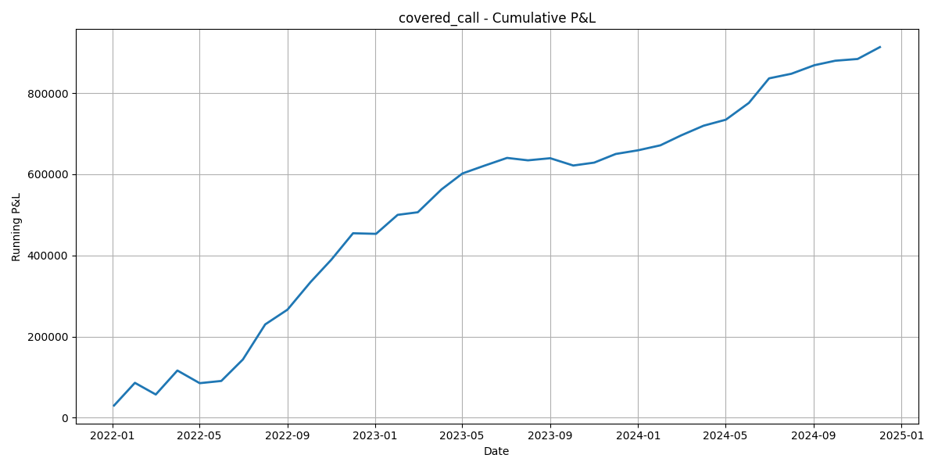
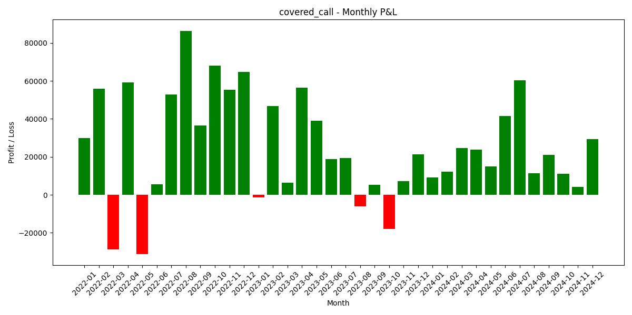

Covered Call was the strongest performer in the entire study by every metric — the highest Sharpe ratio (3.14), the highest win rate (86.1%), and by far the lowest maximum drawdown relative to its total return. This reflects the structural advantage of combining directional exposure with consistent premium income across a period where Nifty was net positive over the 3 years.

3.2 Iron Condor
Logic: Entered every Monday and exited the following Thursday at weekly expiry — producing 140 individual trades over the 36-month window, far more frequent than the other three strategies. The position sells a call spread (short ATM+100 / long ATM+200) and a put spread (short ATM-100 / long ATM-200) simultaneously, profiting when Nifty stays within the short strikes through expiry.
Total P&L (36 months, 140 trades) | ₹66,716
Win Rate | 50.0% (18 of 36 months profitable)
Max Drawdown | ₹1,97,255
Sharpe Ratio | 0.12
Best Month | Nov 2022 (+₹1,88,561)
Worst Month | Oct 2023 (−₹84,182)
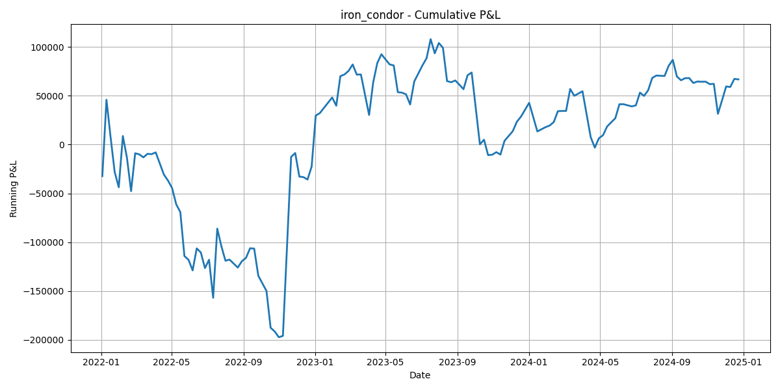
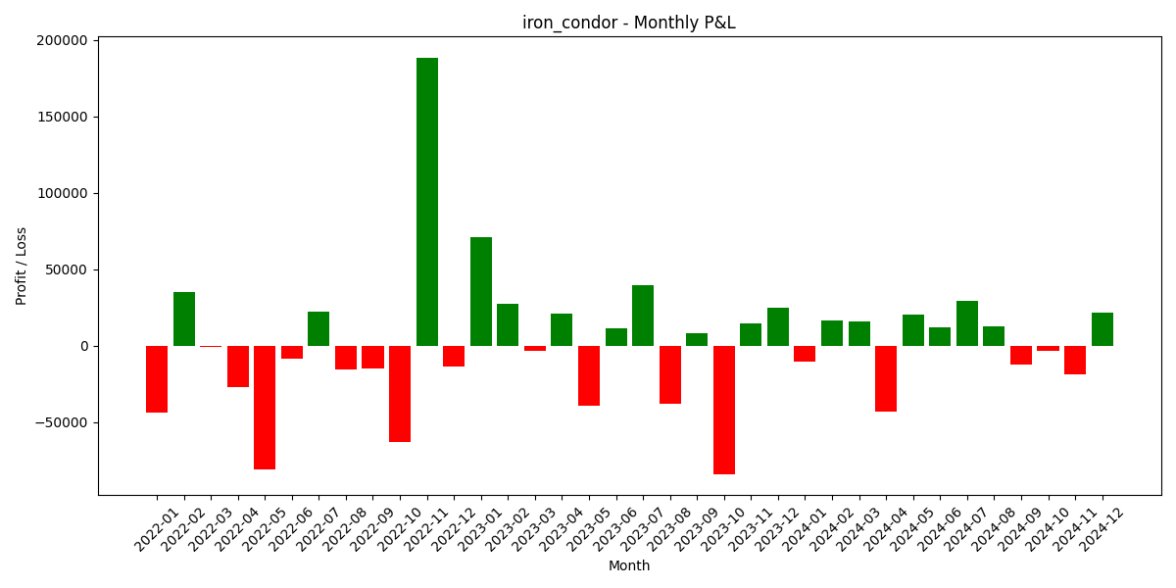

Iron Condor is structurally the most volatile result of the four strategies relative to its modest total return — its drawdown (₹1,97,255) is nearly three times its total P&L. The 50%-win rate and near-zero Sharpe ratio (0.12) indicate that, over this particular 3-year window, the strategy's frequent small wins were largely offset by occasional sharp breaches of its short strikes during trending months.

3.3 Bull Call Spread
Logic: On the first trading day of each month, the strategy buys an ATM call and sells a call 100 points higher, capping both maximum profit and maximum loss. The position is held to monthly expiry. It is a moderately bullish, defined-risk strategy intended to benefit from controlled upward moves without the unlimited risk of a naked option.
Total P&L (36 months) | ₹80,552
Win Rate | 61.1% (22 of 36 months profitable)
Max Drawdown | ₹35,658
Sharpe Ratio | 0.53
Best Month | Oct 2022 (+₹48,150)
Worst Month | Feb 2023 (−₹30,076)
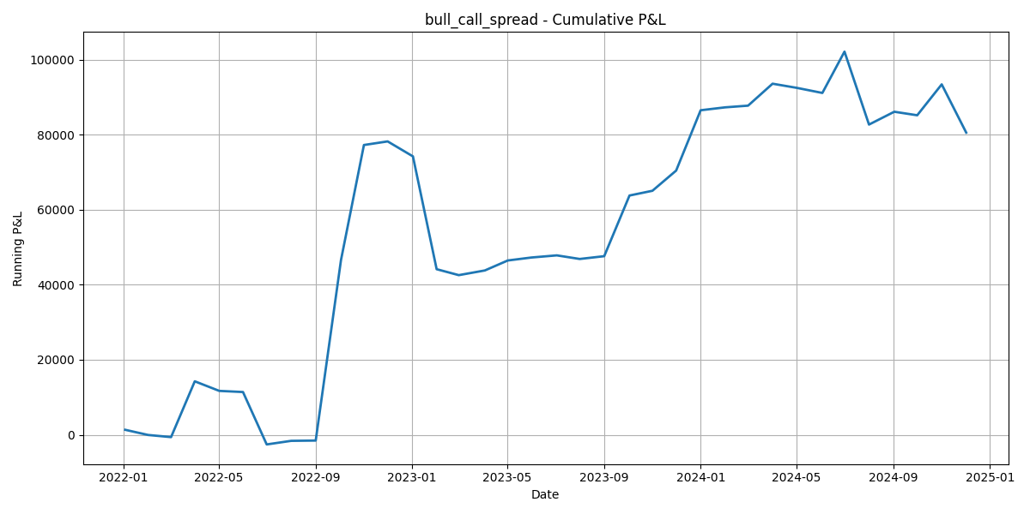
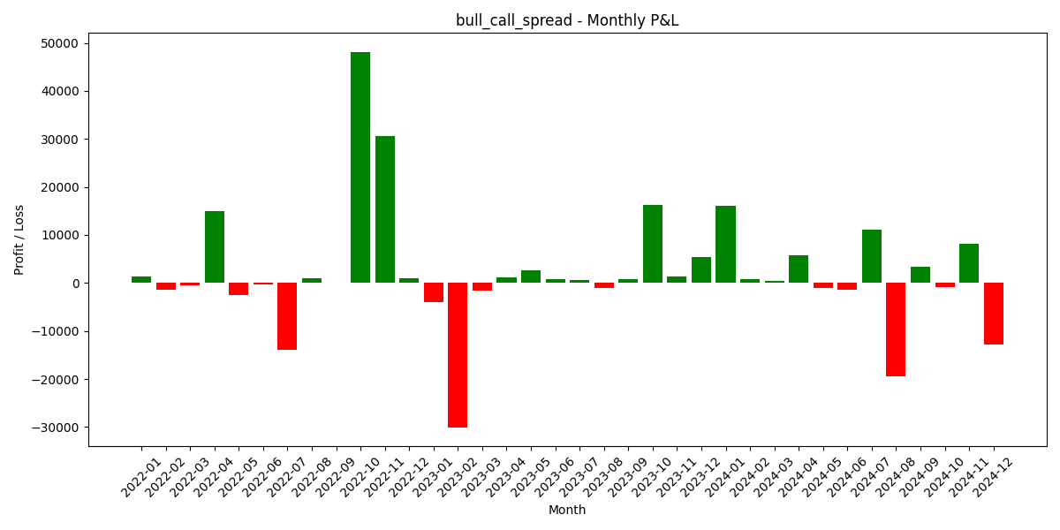

Bull Call Spread delivered modest but positive risk-adjusted returns (Sharpe 0.53), with a defined-risk profile reflected in its comparatively low drawdown of ₹35,658. Its win rate of 61.1% sits in the middle of the four strategies, consistent with a structure designed for moderate directional conviction rather than maximum income or maximum convexity.

3.4 Long Straddle
Logic: Entered one day before each monthly Nifty expiry by buying both an ATM call and an ATM put, intended to capture sharp moves around event-driven catalysts (RBI policy, Union Budget, elections). The position is held to expiry, profiting only if the underlying moves significantly in either direction before time decay erodes both premiums.
Total P&L (36 months) | −₹8,48,257
Win Rate | 13.9% (5 of 36 months profitable)
Max Drawdown | ₹8,48,257
Sharpe Ratio | −3.59
Best Month | Dec 2023 (+₹20,903)
Worst Month | Feb 2023 (−₹71,745)
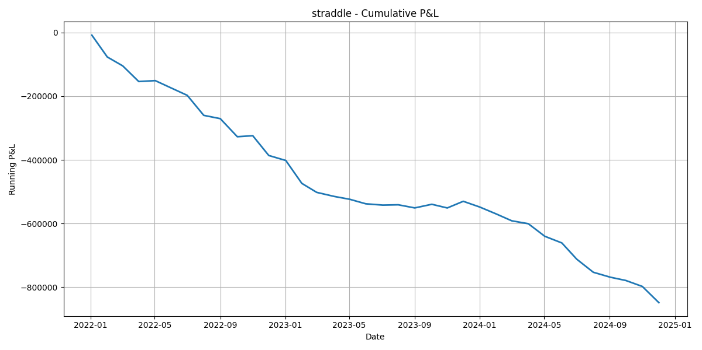
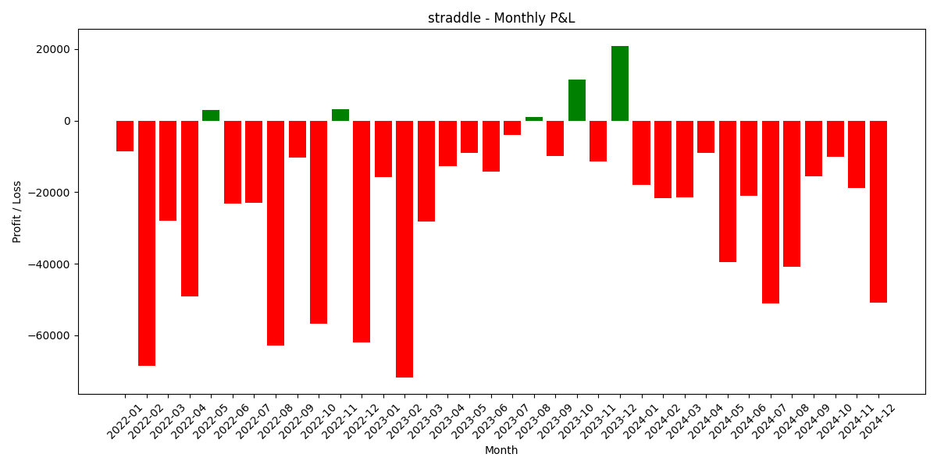

Long Straddle was the weakest performer by a wide margin — a negative Sharpe ratio (−3.59) and only a 13.9% win rate. This is an honest result, not a calculation error: a straddle held mechanically every month decays from time value in the large majority of months where Nifty does not move sharply enough to overcome the combined call-and-put premium paid. The strategy's logic is built for occasional large moves, not steady monthly deployment, and the regime-by-regime breakdown in Section 4 returns to this distinction in detail.

